**St. Paul’s RC Academy**

**School Improvement Report**

**Session 2022-2023**



St. Paul’s RC Academy,

90 Gillburn Road

Dundee. DD3 0EH

Tel 01382 307701

Email: st-pauls@dundeecity.gov.uk

This document shares and celebrates the improvements in our School and embraces all ages and stages. It is based upon our School Improvement Plan for session 2022-23

|  |
| --- |
| **Our School Vision**  ***Guided by the values of St Paul our patron, we strive to develop and nurture ambition, and the many gifts of those in our community, by providing equity of opportunity, challenge and support.***  **Our School Values**  ***FAIR Fairness - Ambition - Inclusion - Respect FAIR***  **Our Aims:**    **1 Learning and Teaching**  To create a learning culture of the highest aspirations and motivation where all young people are engaged and challenged to achieve their full potential. In every classroom, dynamic, varied teaching and learning allows pupils to become successful learners, confident Individuals, responsible citizens and effective contributors to society.  **2 Ethos and Life of our School**  To ensure that our Gospel Values are embedded throughout our community and that we work and learn together in a safe, secure and happy environment, setting high expectations for all where our young people will thrive.  **3 Personal Support**  To nurture individuality and uniqueness in all members of the St Pauls community. To provide the highest level of support we will work closely with other professionals and continue to extend our partnerships to ensure all our Young People are given equal opportunities to maximise their potential.  **4 Assessment, Attainment and Achievement**  The staff at St Pauls will ensure that pupils are supported in their learning journey by giving them a clear picture of what they should learn, share criteria for success in every lesson and encourage engagement in opportunities for wider achievement.  **5 Professionalism and Professional Development**  We are committed to self-evaluation to identify ways that we can improve our professional skills and knowledge through Career Long Professional Learning to the benefit of our young people.  **6 Working with Partners**  To develop high quality partnerships to enable our curriculum to offer the widest possible range of academic and vocational courses to ensure all our Young People are given equal opportunities to maximise their potential and the appropriate support to enhance learning and teaching.    **Context of the School:**  St Paul’s RC Academy opened in 2008 following the merger of Lawside Academy and St Saviour’s High School. As a result, the catchment area for St Paul’s is vast, spanning from Broughty Ferry to Ardler and St. Mary’s, and beyond to Denhead of Gray, covering all areas North of the Kingsway. The school roll has been increasing over the last few years and there are currently 1002 young people in our school community. All young people work through the Broad General Education in S1 – S3, moving on to the Senior Phase in S4 – S6. The curriculum offers our young people some personalisation and choice in a wide range of subjects, at various levels, leading to certification and a positive destination. There are many and varied opportunities for extra-curricular activities and wider achievement, often leading to additional qualifications. The school have many partners involved in providing support, learning experiences and wider opportunities to our pupils. Working with our parents is a priority and we communicate daily through the School APP, Twitter, the school website or Group Call, |

**Data reflecting our pupil attainment for the session 2022 - 2023**

**S3 Curriculum for Excellence**

**BGE Attainment Data 2018- 2019** (National Measure - percentages of S3 pupils achieving level 3 or better)

|  |  |  |  |  |
| --- | --- | --- | --- | --- |
|  | *Reading* | *Writing* | *Talking & Listening* | *Numeracy* |
| **S3** (CFE Third Level) | **89%** | **89%** | **89%** | **80%** |

**From the figures above, 43% achieved Level 4 in Reading, Writing, Talking & Listening, and 37% achieved Level 4 in Numeracy.**

**BGE Attainment Data 2019- 2020** (National Measure - percentages of S3 pupils achieving level 3 or better)

|  |  |  |  |  |
| --- | --- | --- | --- | --- |
|  | *Reading* | *Writing* | *Talking & Listening* | *Numeracy* |
| **S3** (CFE Third Level) | **88%** | **88%** | **88%** | **82%** |

**From the figures above, 53% achieved Level 4 in Reading, 52% in Writing, 53% in Talking & Listening, and 41% achieved Level 4 in Numeracy.**

**BGE Attainment Data 2020- 2021** (National Measure - percentages of S3 pupils achieving level 3 or better)

|  |  |  |  |  |
| --- | --- | --- | --- | --- |
|  | *Reading* | *Writing* | *Talking & Listening* | *Numeracy* |
| **S3** (CFE Third Level) | **79%** | **79%** | **80%** | **80%** |

**From the figures above, 53% achieved Level 4 in Reading, 52% in Writing, 60% in Talking & Listening, and 49% achieved Level 4 in Numeracy.**

**BGE Attainment Data 2021- 2022** (National Measure - percentages of S3 pupils achieving level 3 or better)

|  |  |  |  |  |
| --- | --- | --- | --- | --- |
|  | *Reading* | *Writing* | *Talking & Listening* | *Numeracy* |
| **S3** (CFE Third Level) | **85%** | **80%** | **86%** | **77%** |

**From the figures above, 54% achieved level 4 in Reading, 53% in writing, 55% in Talking and Listening, and 45% achieved level 4 in Numeracy.**

**BGE Attainment Data 2022- 2023** (National Measure - percentages of S3 pupils achieving level 3 or better)

|  |  |  |  |  |
| --- | --- | --- | --- | --- |
|  | *Reading* | *Writing* | *Talking & Listening* | *Numeracy* |
| **S3** (CFE Third Level) | **77%** | **77%** | **77%** | **75%** |

**Senior Phase Attainment Data**

**Local Benchmarking Measure: Literacy and Numeracy by SCQF Level**

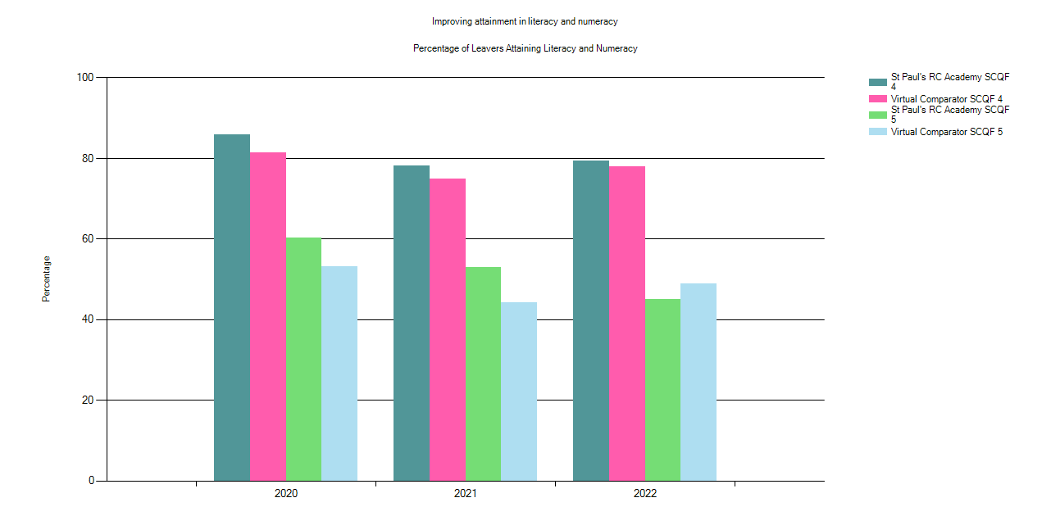

|  |  |  |  |  |
| --- | --- | --- | --- | --- |
| DisplayName | Year | % Level 4 Literacy and Numeracy | % Level 5 Literacy and Numeracy | Number in Cohort |
| St Paul's RC Academy | 2022 | 79.44 | 45 | 180 |
| Virtual Comparator | 2022 | 78.06 | 48.94 | 1800 |
| Dundee City | 2022 | 85.22 | 59.9 | 1394 |
| The Tayside Collaborative | 2022 | 86.44 | 63.63 | 4166 |
| The National Establishment | 2022 | 89.58 | 68.16 | 55211 |
| St Paul's RC Academy | 2021 | 78.06 | 52.9 | 155 |
| Virtual Comparator | 2021 | 74.97 | 44.26 | 1550 |
| Dundee City | 2021 | 85.04 | 65.33 | 1223 |
| The Tayside Collaborative | 2021 | 87.96 | 68.8 | 3836 |
| The National Establishment | 2021 | 90.16 | 70.55 | 50719 |
| St Paul's RC Academy | 2020 | 85.82 | 60.28 | 141 |
| Virtual Comparator | 2020 | 81.49 | 53.19 | 1410 |
| Dundee City | 2020 | 85.43 | 63.92 | 1167 |
| The Tayside Collaborative | 2020 | 87.61 | 67.38 | 3406 |
| The National Establishment | 2020 | 89.61 | 68.74 | 47430 |

**Local Benchmarking Measure: Candidate Initial Destinations**

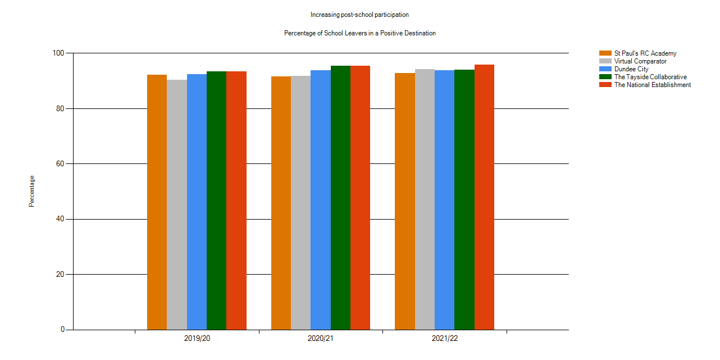

|  |  |  |  |
| --- | --- | --- | --- |
| **Establishment** | **Year** | **% of Schools Leavers in a Positive Destination** | **Number in Cohort** |
| St Paul's RC Academy | 2021/22 | 92.78 | 180 |
| Virtual Comparator | 2021/22 | 94.11 | 1800 |
| Dundee City | 2021/22 | 93.9 | 1394 |
| The Tayside Collaborative | 2021/22 | 94.05 | 4166 |
| The National Establishment | 2021/22 | 95.74 | 55211 |
| St Paul's RC Academy | 2020/21 | 91.61 | 155 |
| Virtual Comparator | 2020/21 | 91.87 | 1550 |
| Dundee City | 2020/21 | 93.7 | 1223 |
| The Tayside Collaborative | 2020/21 | 95.41 | 3836 |
| The National Establishment | 2020/21 | 95.48 | 50719 |
| St Paul's RC Academy | 2019/20 | 92.2 | 141 |
| Virtual Comparator | 2019/20 | 90.35 | 1410 |
| Dundee City | 2019/20 | 92.29 | 1167 |
| The Tayside Collaborative | 2019/20 | 93.39 | 3406 |
| The National Establishment | 2019/20 | 93.36 | 47430 |

**Local Benchmarking Measure: Improving Attainment for All**

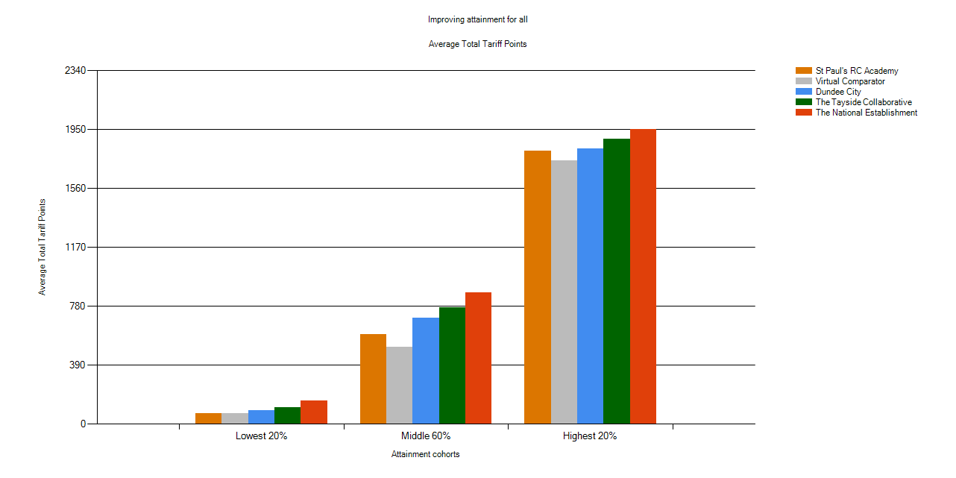

|  |  |  |  |  |  |  |  |  |
| --- | --- | --- | --- | --- | --- | --- | --- | --- |
| **Establishment** | **Year** | **Lowest 20%** | **Lowest 20% Grade Neutral** | **Middle 60%** | **Middle 60% Grade Neutral** | **Highest 20%** | **Highest 20% Grade Neutral** | **Number in Cohort** |
| St Paul's RC Academy | 2022 | 69 | 57 | 592 | 399 | 1810 | 1113 | 180 |
| Virtual Comparator | 2022 | 68 | 57 | 511 | 352 | 1744 | 1090 | 1800 |
| Dundee City | 2022 | 88 | 69 | 701 | 472 | 1826 | 1123 | 1394 |
| The Tayside Collaborative | 2022 | 112 | 86 | 774 | 515 | 1886 | 1150 | 4166 |
| The National Establishment | 2022 | 154 | 117 | 871 | 577 | 1950 | 1194 | 55211 |
| St Paul's RC Academy | 2021 | 48 | 42 | 574 | 385 | 1620 | 1016 | 155 |
| Virtual Comparator | 2021 | 46 | 40 | 435 | 305 | 1532 | 971 | 1550 |
| Dundee City | 2021 | 87 | 69 | 736 | 493 | 1776 | 1089 | 1223 |
| The Tayside Collaborative | 2021 | 127 | 97 | 869 | 572 | 1888 | 1145 | 3836 |
| The National Establishment | 2021 | 164 | 123 | 939 | 616 | 1982 | 1200 | 50719 |
| St Paul's RC Academy | 2020 | 129 | 103 | 677 | 465 | 1649 | 1037 | 141 |
| Virtual Comparator | 2020 | 73 | 62 | 579 | 401 | 1715 | 1076 | 1410 |
| Dundee City | 2020 | 88 | 72 | 732 | 491 | 1844 | 1136 | 1167 |
| The Tayside Collaborative | 2020 | 117 | 92 | 817 | 545 | 1858 | 1140 | 3406 |
| The National Establishment | 2020 | 151 | 116 | 880 | 587 | 1921 | 1175 | 47430 |

**Local Benchmarking Measure: Attainment versus Deprivation**

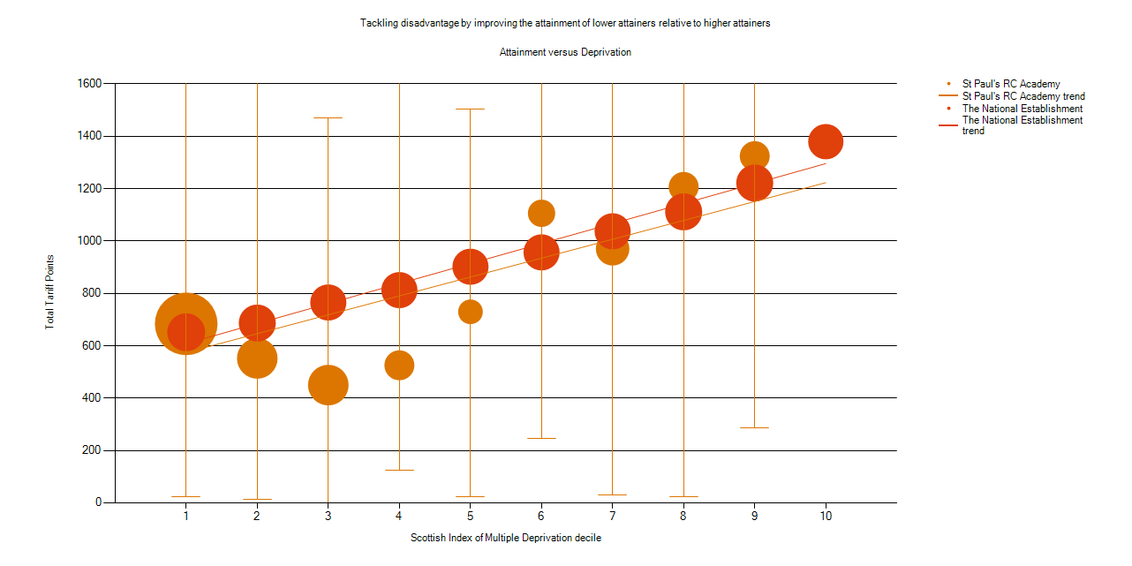

|  |  |  |  |  |  |  |  |  |  |
| --- | --- | --- | --- | --- | --- | --- | --- | --- | --- |
| **Establishment** | **Year** | **Number in Cohort** | **SIMD 1 % of Cohort** | **SIMD 1 Average** | **SIMD 2 % of Cohort** | **SIMD 3 % of Cohort** | **SIMD 3 Average** | **SIMD 4 % of Cohort** | **SIMD 4 Average** |
| St Paul's RC Academy | 2021/22 | 180 | 42.22% | 684 | 13.33% | 13.33% | 450 | 5.56% | 526 |
| The National Establishment | 2021/22 | 55211 | 11.32% | 652 | 10.69% | 9.86% | 765 | 9.75% | 813 |
| St Paul's RC Academy | 2020/21 | 155 | 37.42% | 681 | 21.94% | 14.19% | 575 | 11.61% | 665 |
| The National Establishment | 2020/21 | 50719 | 10.77% | 675 | 10.73% | 9.89% | 804 | 9.59% | 879 |
| St Paul's RC Academy | 2019/20 | 141 | 31.91% | 759 | 23.40% | 12.06% | 885 | 7.09% | 864 |
| The National Establishment | 2019/20 | 47430 | 11.23% | 645 | 10.82% | 9.83% | 768 | 9.51% | 812 |

|  |  |  |  |  |  |  |  |  |  |  |
| --- | --- | --- | --- | --- | --- | --- | --- | --- | --- | --- |
| **SIMD 5 % of Cohort** | **SIMD 5 Average** | **SIMD 6 % of Cohort** | **SIMD 6 Average** | **SIMD 7 % of Cohort** | **SIMD 8 % of Cohort** | **SIMD 8 Average** | **SIMD 9 % of Cohort** | **SIMD 9 Average** | **SIMD 10 % of Cohort** | **SIMD 10 Average** |
| 2.78% | 730 | 3.89% | 1106 | 7.78% | 5.56% | 1207 | 5.56% | 1324 | 0.00% | 0 |
| 9.67% | 902 | 9.40% | 957 | 9.70% | 10.54% | 1112 | 10.34% | 1222 | 8.73% | 1380 |
| 1.29% | 200 | 2.58% | 1081 | 5.81% | 3.87% | 1031 | 1.29% | 659 | 0.00% | 0 |
| 9.70% | 956 | 9.49% | 1016 | 9.88% | 10.44% | 1149 | 10.33% | 1256 | 9.16% | 1421 |
| 4.96% | 864 | 4.96% | 559 | 12.06% | 3.55% | 561 | 0.00% | 0 | 0.00% | 0 |
| 9.54% | 927 | 9.53% | 981 | 9.79% | 10.18% | 1098 | 10.47% | 1213 | 9.11% | 1353 |

**The tables on the following pages show the percentage of pupils in each year group of the Senior Phase achieving awards at SCQF Level 4, Level 5, Level 6 or Level 7 for SQA exams, this equates to National 4, National 5, Higher and Advanced Higher.**

**This is followed by the school Attendance data and the school Exclusion data.**

|  |  |  |  |  |  |  |  |  |  |  |  |
| --- | --- | --- | --- | --- | --- | --- | --- | --- | --- | --- | --- |
| **S4** | **SCQF Level 4 or better** | | |  |  |  |  |  |  |  |  |
|  | Diet |  |  |  |  |  |  |  |  |  |
|  | Awards at A-C | 2016 | 2017 | 2018 | 2019 | 2020 | 2021 | 2022 | 2023 |  |  |
|  | 1 or more | 86% | 89% | 91% | 86% | 94% | 88% | 85% | 92% |  |  |
|  | 2 or more | 84% | 88% | 85% | 80% | 92% | 85% | 83% | 88% |  |  |
|  | 3 or more | 80% | 84% | 78% | 76% | 86% | 81% | 77% | 85% |  |  |
|  | 4 or more | 69% | 79% | 68% | 64% | 79% | 76% | 71% | 74% |  |  |
|  | 5 or more | 54% | 64% | 51% | 49% | 69% | 61% | 52% | 58% |  |  |
|  | 6 or more | 31% | 45% | 20% | 18% | 49% | 35% | 30% | 30% |  |  |
|  |  |  |  |  |  |  |  |  |  |  |  |
|  | **SCQF Level 5 or better** | | |  |  |  |  |  |  |  |  |
|  |  | Diet |  |  |  |  |  |  |  |  |  |
|  | Awards at A-C | 2016 | 2017 | 2018 | 2019 | 2020 | 2021 | 2022 | 2023 |  |  |
|  | 1 or more | 52% | 74% | 70% | 64% | 81% | 73% | 72% | 76% |  |  |
|  | 2 or more | 36% | 59% | 54% | 51% | 68% | 62% | 58% | 62% |  |  |
|  | 3 or more | 26% | 43% | 42% | 36% | 58% | 54% | 46% | 44% |  |  |
|  | 4 or more | 19% | 30% | 33% | 27% | 43% | 36% | 39% | 32% |  |  |
|  | 5 or more | 14% | 19% | 22% | 14% | 32% | 26% | 27% | 22% |  |  |
|  | 6 or more | 9% | 13% | 12% | 7% | 21% | 12% | 15% | 16% |  |  |
|  |  |  |  |  |  |  |  |  |  |  |  |

|  |  |  |  |  |  |  |  |  |  |  |  |
| --- | --- | --- | --- | --- | --- | --- | --- | --- | --- | --- | --- |
| **S5** | **SCQF Level 5 or better** | | |  |  |  |  |  |  |  |  |
|  | Diet |  |  |  |  |  |  |  |  |  |
|  | Awards at A-C | 2016 | 2017 | 2018 | 2019 | 2020 | 2021 | 2022 | 2023 |  |  |
|  | 1 or more | 69% | 63% | 79% | 75% | 70% | 84% | 75% | 74% |  |  |
|  | 2 or more | 55% | 50% | 74% | 64% | 61% | 75% | 67% | 65% |  |  |
|  | 3 or more | 50% | 44% | 61% | 53% | 55% | 70% | 64% | 58% |  |  |
|  | 4 or more | 44% | 36% | 53% | 47% | 51% | 58% | 55% | 54% |  |  |
|  | 5 or more | 34% | 29% | 41% | 43% | 46% | 49% | 48% | 46% |  |  |
|  | 6 or more | 32% | 21% | 36% | 37% | 38% | 42% | 40% | 39% |  |  |
|  |  |  |  |  |  |  |  |  |  |  |  |
|  | **SCQF Level 6 or better** | | |  |  |  |  |  |  |  |  |
|  |  | Diet |  |  |  |  |  |  |  |  |  |
|  | Awards at A-C | 2016 | 2017 | 2018 | 2019 | 2020 | 2021 | 2022 | 2023 |  |  |
|  | 1 or more | 39% | 31% | 46% | 47% | 46% | 43% | 52% | 45% |  |  |
|  | 2 or more | 27% | 19% | 29% | 34% | 30% | 36% | 31% | 34% |  |  |
|  | 3 or more | 20% | 12% | 17% | 25% | 19% | 28% | 20% | 28% |  |  |
|  | 4 or more | 14% | 7% | 14% | 14% | 9% | 16% | 12% | 19% |  |  |
|  | 5 or more | 6% | 2% | 4% | 7% | 5% | 8% | 6% | 8% |  |  |
|  |  |  |  |  |  |  |  |  |  |  |  |

|  |  |  |  |  |  |  |  |  |  |  |  |
| --- | --- | --- | --- | --- | --- | --- | --- | --- | --- | --- | --- |
| **S6** | **SCQF Level 5 or better** | | |  |  |  |  |  |  |  |  |
|  | Diet |  |  |  |  |  |  |  |  |  |
|  | Awards at A-C | 2016 | 2017 | 2018 | 2019 | 2020 | 2021 | 2022 | 2023 |  |  |
|  | 1 or more | 67% | 71% | 64% | 79% | 81% | 70% | 84% | 76% |  |  |
|  | 2 or more | 60% | 58% | 51% | 74% | 65% | 61% | 75% | 68% |  |  |
|  | 3 or more | 52% | 51% | 47% | 64% | 55% | 57% | 71% | 64% |  |  |
|  | 4 or more | 48% | 47% | 41% | 59% | 49% | 53% | 60% | 56% |  |  |
|  | 5 or more | 38% | 40% | 35% | 48% | 48% | 48% | 51% | 49% |  |  |
|  | 6 or more | 35% | 35% | 29% | 41% | 44% | 43% | 44% | 43% |  |  |
|  |  |  |  |  |  |  |  |  |  |  |  |
|  | **SCQF Level 6 or better** | | |  |  |  |  |  |  |  |  |
|  |  | Diet |  |  |  |  |  |  |  |  |  |
|  | Awards at A-C | 2016 | 2017 | 2018 | 2019 | 2020 | 2021 | 2022 | 2023 |  |  |
|  | 1 or more | 42% | 42% | 39% | 49% | 57% | 50% | 48% | 52% |  |  |
|  | 2 or more | 33% | 32% | 28% | 36% | 40% | 36% | 40% | 37% |  |  |
|  | 3 or more | 27% | 27% | 21% | 28% | 37% | 28% | 34% | 29% |  |  |
|  | 4 or more | 21% | 23% | 17% | 22% | 26% | 20% | 27% | 23% |  |  |
|  | 5 or more | 13% | 18% | 11% | 17% | 17% | 15% | 20% | 16% |  |  |
|  |  |  |  |  |  |  |  |  |  |  |  |
|  | **SCQF Level 7 or better** | | |  |  |  |  |  |  |  |  |
|  |  | Diet |  |  |  |  |  |  |  |  |  |
|  | Awards at A-C | 2016 | 2017 | 2018 | 2019 | 2020 | 2021 | 2022 | 2023 |  |  |
|  | 1 or more | 9% | 8% | 8% | 12% | 21% | 11% | 12% | 6% |  |  |
|  | 2 or more | 1% | 2% | 1% | 2% | 1% | 1% | 1% | 1% |  |  |
|  | 3 or more | 0% | 1% | 0% | 1% | 0% | 0% | 0% | 0% |  |  |
|  |  |  |  |  |  |  |  |  |  |  |  |

**School Level Exclusion Rates (Incidents per 1000 pupils)**

|  |  |  |  |  |  |
| --- | --- | --- | --- | --- | --- |
| **Establishment** | **2018/19** | **2019/20** | **2020/21** | **2021/22** | **2022/23** |
| St Paul’s RC Academy | 26.1 | 17.9 | 18.3 | 26.3 | 32.1 |
| Dundee City | 47.5 | 29.1 | 23.4 | 52.0 | 33.5 |

**Attendance Rates**

|  |  |  |  |  |  |
| --- | --- | --- | --- | --- | --- |
| **Establishment** | **2018/19** | **2019/20** | **2020/21** | **2021/22** | **2022/23** |
| St Paul’s RC Academy | 88.2% | 87.8% | 87.4% | 83.9% | 83.6% |
| Dundee City | 89.0% | 88.0% | 90.4% | 85.9% | 88.5% |

**Review of Improvement Progress for Session 2022-2023**

**Cycle of Improvement** *Based on Summary Self-evaluation, School Improvement Report,*

*Annual Audit, Extended Review, and feedback from Key Partners*

**Improvement Priorities for Session 2022-2023**

Please visit <https://education.gov.scot/what-we-do/inspection-and-review/reports> for or HMIE Inspection Reports.

**Further Information can be found at:**

|  |  |  |  |
| --- | --- | --- | --- |
|  |  |  | [Image result for additional support needs](https://www.google.co.uk/imgres?imgurl=http://www.roevalleyintegrated.co.uk/cmsfiles/items/pageimages/308.5_auto/sen_1.gif&imgrefurl=http://www.roevalleyintegrated.co.uk/curriculum-and-assessment/additional-needs/&docid=oU3qQprNpIx0TM&tbnid=Le4edm8pi6vWGM:&vet=10ahUKEwjk5syCwNnWAhWoCMAKHbSnAP8QMwg1KBAwEA..i&w=308&h=140&hl=en&safe=strict&bih=697&biw=1004&q=additional%20support%20needs&ved=0ahUKEwjk5syCwNnWAhWoCMAKHbSnAP8QMwg1KBAwEA&iact=mrc&uact=8)  Dundee Education Plan  <https://www.dundeecity.gov.uk/sites/default/files/publications/annual_education_plan_2017-18.pdf> |
| National Improvement Framework  <http://www.gov.scot/Publications/2016/01/8314> | HGIOS 4 Self-evaluation <https://education.gov.scot/improvement/Documents/Frameworks_SelfEvaluation/FRWK2_NIHeditHGIOS/FRWK2_HGIOS4.pdf> | Tayside Plan C&FS  Tayside_Plan 1a.pdf' |  |

|  |  |  |  |
| --- | --- | --- | --- |
|  |  |  |  |